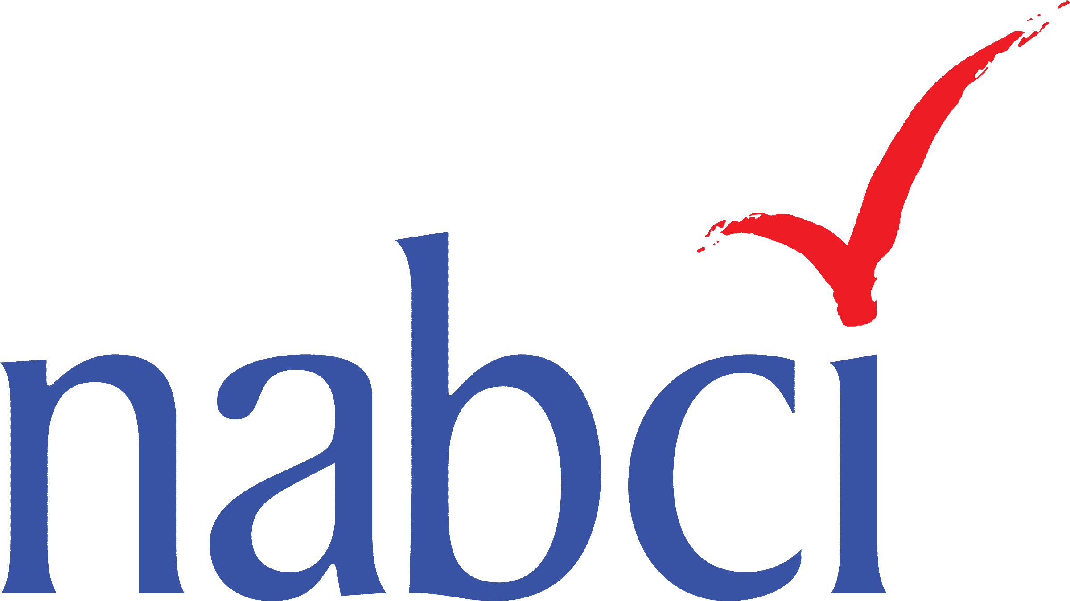

North American Bird Conservation Initiative- US Committee
31 January-1 February 2018
U.S. Fish and Wildlife Service, 5275 Leesburg Pike, Falls Church, VA 22041
DRAFT AGENDA v10January2017

Day 1

8:00 Gather with light breakfast
Note: Attendees must check in at security desk; please leave plenty of time for security check

8:30 Welcome and Introductions

8:45 Host Welcome- USFWS

9:00 NABCI Coordinator Overview- Judith Scarl, NABCI
Related Materials: NABCI Work Plan Progress Report

9:15 Private and Working Lands Subcommittee report and discussion – Todd Fearer, Appalachian Mountain Joint Venture
NABCI 2017-2021 Strategic Plan Goal 2, Subgoal 1e: Promote and advance bird conservation objectives on both private and public lands.
Purpose: Provide an update to the NABCI Committee on the short- and long-term action items and deliverables the Subcommittee has identified for our workplan objectives, focusing on collaborative efforts with the Communications, Monitoring, and HD Subcommittees and engaging novel partners to advance our Subcommittee’s objectives.
Preferred Outcomes: Committee members have understanding of and provide any suggestions/feedback on the Subcommittee’s action items and implementation timeline for our workplan.

9:35-10:30 NABCI 2017-2021 Strategic Plan Goal 1, Subgoal 1a: Work collaboratively across countries to support partnership development that will advance full annual cycle conservation of migratory birds and their habitats.

International Subcommittee report and discussion - Greg Butcher, US Forest Service/Deb Hahn, Association of Fish and Wildlife Agencies
NABCI 2017-2021 Strategic Plan Goal 1, Subgoal 1a. Work collaboratively across countries to support partnership development that will advance full annual cycle conservation of migratory birds and their habitats.
Purpose: Discuss implementation of the North American Vision for Hemispheric Bird Conservation and ways to align with Americas Flyways Framework; propose methods of engaging with the International Ornithological Congress
Preferred Outcomes: Committee provides input on recommended actions that will advance the Vision

NABCI 2017-2021 Strategic Plan Goal 1, Subgoal 1a4 Work with Coordinators of NABCI Canada and Mexico to support redevelopment of NABCI Canada Committee and identify shared priorities for collaboration between countries
NABCI Canada Progress and Partnership (TENTATIVE)- Marie-France Noel, NABCI Canada Coordinator, Canadian Wildlife Service
Purpose: Share information about NABCI Canada’s redevelopment, including priorities they have identified for NABCI Canada to address moving forward
Preferred Outcomes: US Committee understands status, focus, and direction of NABCI Canada and considers future opportunities for collaboration.

NABCI Mexico Progress and Partnership (TENTATIVE)- Humberto Berlanga, NABCI Mexico Coordinator, CONABIO
Purpose: Share information about NABCI Mexico, including its structure, focus, and projects.
Preferred Outcomes: US Committee understands status, focus, and direction of NABCI Mexico and considers future opportunities for collaboration.

10:30-10:45 Break

10:45 Monitoring Subcommittee Report, Discussion, and Affiliated Projects- Gray Anderson, Virginia DGIF/Viviana Ruiz Gutierrez, Cornell Lab of Ornithology
NABCI 2017-2021 Strategic Plan Goal 2, Subgoal 1a: Promote and advance bird monitoring that is integrated into strategic habitat conservation
Purpose: Update Committee on efforts to regroup and identify strong direction for Subcommittee
Preferred Outcomes: Committee provides advice on path forward for Subcommittee, as appropriate

11:00 Monitoring Subcommittee Affiliated Project 1: Unified Science Team (UST)’s Efforts to Identify National Needs for Measuring Net Landscape Change- Jorge Coppen, USFWS
NABCI 2017-2021 Strategic Plan Goal 2, Subgoal 1c: Support efforts to coordinate and unify science capacity among national bird conservation partnerships to more effectively address shared ecological science challenges and needs; Subgoal 1c1a: Monitor and support efforts to identify common needs to measure and evaluate net landscape change between the bird conservation and broader communities
Related materials: White paper on Net Landscape Change Needs and Recommendations
Purpose: Provide overview of UST Net Landscape Change team’s progress on identifying national needs to measure net landscape change to further bird conservation objectives; get feedback on which recommendations are realistic to achieve and seek input on strategy to communicate with appropriate audiences
Preferred Outcomes: NABCI Committee members evaluate which recommendations are realistic to achieve and assist with efforts to communicate UST’s recommendations to agency leadership.

11:20 Human Dimensions Subcommittee report and discussion- Ashley Gramza, Virginia Tech/Tammy VerCauteren, Bird Conservancy of the Rockies
NABCI 2017-2021 Strategic Plan Goal 2, Subgoal 1b: Enable bird conservation partners to integrate human dimensions science and tools into bird conservation efforts.
Related Materials: Human Dimensions Subcommittee 2017 Accomplishments
Purpose: Present HD Subcommittee priorities for 2018 and Bird Conservation HD Success Story Map
Preferred Outcomes: Committee provides feedback on HD Success Story Map and Subcommittee priorities

12:00-1:30 LUNCH

1:30 Communications Subcommittee report and discussion - EJ Williams, American Bird Conservancy
NABCI 2017-2021 Strategic Plan Goal 1, Subgoal 2: Strengthen communication within the bird conservation community.
Purpose: Present Committee with proposed tag line; update Committee on blog status and statistics
Preferred Outcomes: Committee approves NABCI tag line; Committee members provide feedback on utility of blog and continue to commit to contributing one article per year per partner

1:50 The Relevance of Bird Conservation: Initial Messaging for Partner Outreach- Steve Albert, Institute for Bird Populations
NABCI 2017-2021 Strategic Plan Goal 3, Subgoal 2b: Demonstrate bird conservation’s strong ties to healthy land, water, and people in order to communicate relevance beyond birds; Subgoal 2b2: Develop initial talking points supporting bird conservation relevancy for meetings with agency leadership, funding organizations, and non-traditional partners
Purpose: Update Committee on progress developing document that provides examples of the relevancy of birds and bird habitat conservation, continue to ensure Committee feels that this project is on track and optimally useful
Preferred Outcomes: Committee provides feedback on Relevancy document and how to ensure document is most useful across NABCI partnership; Committee understands how to use both current document and future one-pager derived from current longer document

2:10 National Bird Conservation Priorities- Judith Scarl, NABCI
NABCI 2017-2021 Strategic Plan Goal 1, Subgoal 1: Support, develop, integrate, and promote priorities of regional, national, and international bird conservation partnerships.
NABCI 2017-2021 Strategic Plan Goal 3, Subgoal 1: Facilitate coordinated communication with government leadership about highest priority programs, initiatives, and needs of bird conservation.
Purpose: Update Committee on progress towards developing a short list of national bird conservation priorities that community wants to highlight; share results of survey asking Committee members to rank thorough list of priorities; discuss next steps
Preferred Outcomes: Committee provides feedback on survey results and does “reality check” on anticipated utility of documents, evaluates how likely Committee members are to use documents

3:00 Break (15 minutes)

3:15 Follow-up Discussion on Priorities OR other topic as needed

3:45 The Status of Bird Conservation Policy, Regulations, and Budgets
NABCI 2017-2021 Strategic Plan Goal 3: Inform and support effective policy to advance bird conservation
Purpose: Over the last few months, several national policies that may impact bird conservation have been proposed, modified, or implemented. This informational session will provide an opportunity for NABCI partners to learn about these policies.
Proposed Outcomes: Committee members and partners understand the current status of policy changes and how they will be implemented (as applicable).
3:45 Topic Introduction, Purpose, and Ground Rules- Gordon Myers, NC Wildlife Resources Commission
3:50 Migratory Bird Treaty Act: DOI Solicitor’s Opinion on MBTA interpretation and how USFWS policy will change as a result of this interpretation (Information Only)- Jerome Ford, US Fish and Wildlife Service
4:05 National Environmental Policy Act (NEPA) Environmental Review Process- Proposed Changes- USFS Representative
4:15 Current Status of Federal Budgets and Implications for Bird Conservation- Round Robin, all Federal partners

4:30 Alliance for America’s Fish and Wildlife- Recovering America’s Wildlife Act-
Sean Saville, Association of Fish and Wildlife Agencies
NABCI 2017-2021 Strategic Plan Goal 3, Subgoal 1b2: Coordinate with Blue Ribbon Panel to secure viewer-based funding for bird conservation
Purpose: Brief Committee on status of Alliance for America’s Fish and Wildlife efforts to support a bill directing $1.3 billion dollars of annual funding to support State Wildlife Action Plans. Inform Committee about specifics of legislation and their potential implications, such as a) what funding would be eligible for match; b) how this relates to or could affect existing funding sources, such as Pittman-Robertson and State Wildlife Grants; c) constraints on where this funding could come from.
Preferred Outcomes: Committee considers NABCI’s role in Alliance for America’s Fish and Wildlife and charges one or more Subcommittees with engaging in these efforts, as applicable. Discussion may be continued in Thursday morning session.

4:55 Exciting Special Surprise- Todd Fearer, Appalachian Mountain Joint Venture

5:00 Adjourn

NABCI HAPPY HOUR

Thursday, 1 February 2018

8:00 Gather with light breakfast
Note: Attendees must pass through security; please leave plenty of time for security check

Legislative and Policy Discussions, Continued
NABCI 2017-2021 Strategic Plan Goal 3: Inform and support effective policy to advance bird conservation; Subgoal 1- Facilitate coordinated communication with government leadership about highest priority programs, initiatives, and needs of bird conservation.

8:30 Legislative and Policy Subcommittee report and discussion - Jennifer Cipolletti, American Bird Conservancy
Purpose: Report on October 2017 Farm Bill Hill event, discuss future directions for bird conservation policy messaging, continue discussions from Wednesday afternoon as necessary.
Preferred Outcomes: Strategy for outreach on coordinated messaging; finalize timing for 2018 priority legislative topics; Committee members help identify co-chair options for Subcommittee; agenda item provides lead-in for focused discussion on next State of the Birds topic

8:55 State of the Birds Subcommittee discussion- Ken Rosenberg, Cornell Lab of Ornithology and American Bird Conservancy/Tom Moorman, Ducks Unlimited
NABCI 2017-2021 Strategic Plan Goal 2, Subgoal 1d1: Produce State of the Birds reports that synthesize science and align with key policy programs or initiatives to provide an effective communication tool to encourage science-based conservation policy
Purpose: Following up on the Legislative and Policy discussions, Subcommittee will discuss needs for future outreach and communications around this report and Farm Bill initiative. Additional discussion on whether there is a critical topic NABCI would like to highlight in a 2018 State of the Birds report.
Preferred Outcomes: Committee members understand and commit to advancing Farm Bill State of the Birds outreach in ways appropriate for their organization. Committee decides on the topic of a 2018 State of the Birds report or decides not to create a report in 2018.

9:15 Parking Lot/Follow Up from Day 1 Discussions

10:00 BREAK

Move to Closed Session- NABCI Business/Governance (for NABCI Committee Members only)

10:15 Executive Council Membership- Jerome Ford, US Fish and Wildlife Service/Gordon Myers, NC Wildlife Resources Commission
NABCI 2017-2021 Strategic Plan Goal 1, Subgoal 1d: Maintain an effective US NABCI Committee
Purpose: NGO and Federal Representative terms end at winter 2018 meeting; like organizations nominate individual for each of these positions.
Preferred Outcomes: Committee votes to approve subgroup nominations for Executive Council seats.

10:30 Ad Hoc Awards Subcommittee
NABCI 2017-2021 Strategic Plan Goal 1, Subgoal 2c: Recognize leadership within the bird conservation community.
Purpose: Awards Subcommittee will present its recommendation for 2018 Gary T. Myers Award recipient
Preferred Outcomes: Committee selects a candidate to receive award

10:45 NABCI Budget and Future Funding Strategy- Judith Scarl and NABCI Executive Council
NABCI 2017-2021 Strategic Plan Goal 1, Subgoal 1d3: Ensure sufficient resources for NABCI coordination and projects through financial support of NABCI coordinator and other NABCI needs, as appropriate
Purpose: This agenda item will follow up on August 2017 discussions. Coordinator will report progress on encouraging all Committee member organizations to contribute financially to NABCI. Committee will discuss two budgets: in-kind budget estimation for NABCI contributions and “umbrella” NABCI budget that includes project work not administered through AFWA. Executive Council will report back on actions from August meeting.
Preferred Outcomes: NABCI has diverse and strong financial support over the long-term; Committee organizations commit to continuing to seek funding for NABCI.

11:30 Evaluating New Member Applications

11:50 Additional Business

11:55 Determine Next Meeting Host/Venue

12:00 Adjourn

