US North American Bird Conservation Initiative

Mission: The U.S. NABCI Committee facilitates collaborative partnerships that advance biological, social, and scientific priorities for North American bird conservation.
Vision: Healthy and abundant populations of North American birds are valued by future generations and sustained by habitats that benefit birds and people.

U.S. NABCI Goals 2017-2021
Goal 1: Maintain a well-coordinated bird conservation community to achieve strategic conservation.
Goal 2: Facilitate science-based conservation efforts that support healthy bird populations.
Goal 3: Inform and support effective policy to advance bird conservation.

Recent Products and Accomplishments for National and International Bird Conservation
State of the Birds: Farm Bill Special Report Communications: In August 2017, NABCI released a 2017 State of the Birds report focused on how Farm Bill conservation programs benefit birds, farmers, ranchers, and rural communities. NABCI partners featured the report at a Congressional briefing and reception October 2017 in partnership with the American Forest Foundation and Forest Resources Association, and Joint Ventures are using this report to engage Congressional representatives during field tours of local conservation projects.
Building New Partnerships to Benefit Birds and Beyond: Bird conservation goals often align with interest groups whose focus is not exclusively bird conservation. To advance goals documented in our strategic plan, NABCI has engaged new partners such as the National Association of Conservation Districts, American Forest Foundation, and the American Zoological Association; these partnerships will increase NABCI’s relevancy and allow the bird conservation community to work more closely with other organizations to advance similar goals.

Committee Meeting Highlights, 31 January-1 February 2018
State of the Birds 2018: State Wildlife Agencies for Bird Conservation: NABCI committed to producing a State of the Birds report highlighting the role state wildlife agencies play in bird conservation; this report will serve as a major communication tool regarding the Recovering America’s Wildlife Act, legislation that proposes $1.3 billion annually for the implementation of State Wildlife Action Plans. Anticipated release: Winter 2018-2019.
Increasing Tri-National Collaboration: Mexico, Canada, and the US NABCI Committees working together to develop an action plan to implement our North American Vision for Hemispheric Bird Conservation, and the Mexican and Canadian NABCI Coordinators attended the US NABCI meeting to advance this tri-national partnership. NABCI Canada is reactivating its Committee and has identified four major roles for NABCI Canada’s partnership: coordinate, communicate, track bird conservation, and influence policy. NABCI Mexico has five staff members and focuses on promoting and supporting partnerships within Mexico and within Central America, organizing conservation efforts across Mexico, and engaging people in bird conservation.
Demonstrating the Relevance of Bird Conservation: Identifying areas where bird conservation professionals can work with partners to benefit bird conservation and other human interests, such as economics, clean air, clean water, and human health, will yield the highest level of success for bird conservation goals. NABCI has compiled a draft “relevancy toolkit”- short, quantifiable, and sourced examples of how activities that benefit bird conservation also have positive links to other human priorities. NABCI will create a relevancy one-pager template that allows partners to highlight examples that will resonate with their target audience when engaging leaders and non-traditional partners in conservation conversations. Anticipated release: August 2018.
Communicating National Bird Conservation Priorities: NABCI continues to hone a list of bird conservation actions that the majority of partners consider top priorities for the next 3 years. This list of priorities will be used to facilitate coordinated communication with government leadership and non-traditional partners about critical (and achievable) bird conservation actions. Anticipated release: Fall 2018.
Human Dimensions advances bird conservation: To follow up on a one-pager that defines HD and explains how HD can be used to more effectively address existing bird conservation challenges, NABCI is creating a Human Dimensions success story map, highlighting case studies where social science is integrated into bird conservation. Anticipated release: March 2018.
Additional NABCI Highlights

Leveraging the power of partnerships: More than 45 individuals representing 28 organizations came together to advance collaborative bird conservation at the Winter 2018 NABCI meeting. Overall, more than 100 individuals from at least 35 organizations participate on the NABCI Committee, its 7 Subcommittees, and its ad hoc working groups, enabling NABCI to create high-quality products like the State of the Birds report, All-bird Bulletin Blog, Guide to the 2014 Farm Bill, and bird conservation program messaging.
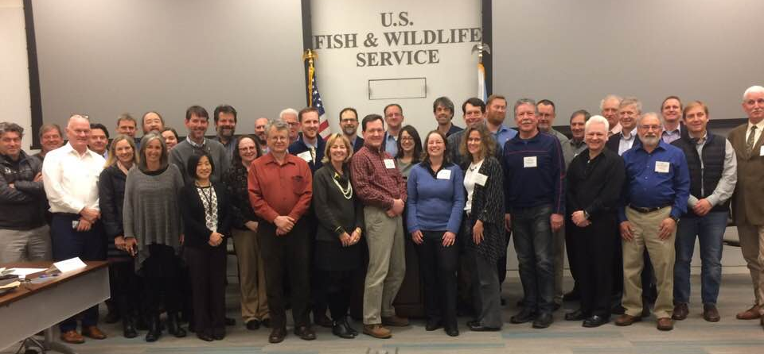

Strengthening tri-national collaboration: From left to right, north to south- Canadian NABCI Coordinator Marie-France Noel, US NABCI Coordinator Judith Scarl, Mexican NABCI Coordinator Humberto Berlanga. This meeting marked the first occasion in many years where all three North American NABCI Coordinators were together in one place!
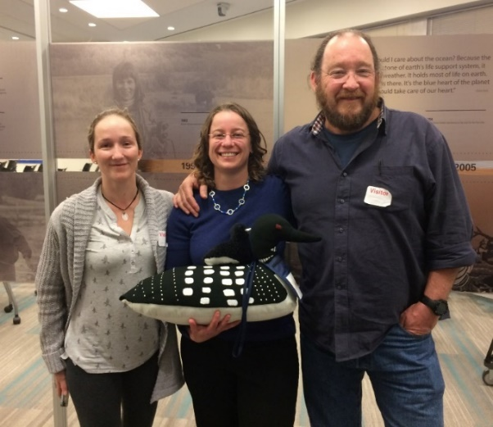

Recognizing accomplishment: Appalachian Mountain Joint Venture (AMJV) Coordinator Todd Fearer presents former AMJV Chair, David Whitehurst, with an award in recognition of his leadership within this JV.
